**Year 12 Quick Check**

1. 
2. Simplify the surd **.**
3. 
4. 
5. Solve **.**
6. Rewrite using index notation **.**
7. Rearrange this equation to make it equal to zero **.**
8. Find the missing length

15

9

?

1. Find the rule for the sequences;
2. -3, 1, 5, 9…
3. 2, 4, 8, 16…
4. For the straight line graph below;
5. State the gradient.
6. State the coordinates where it intersects the y axis.
7. Write the equation of the line.

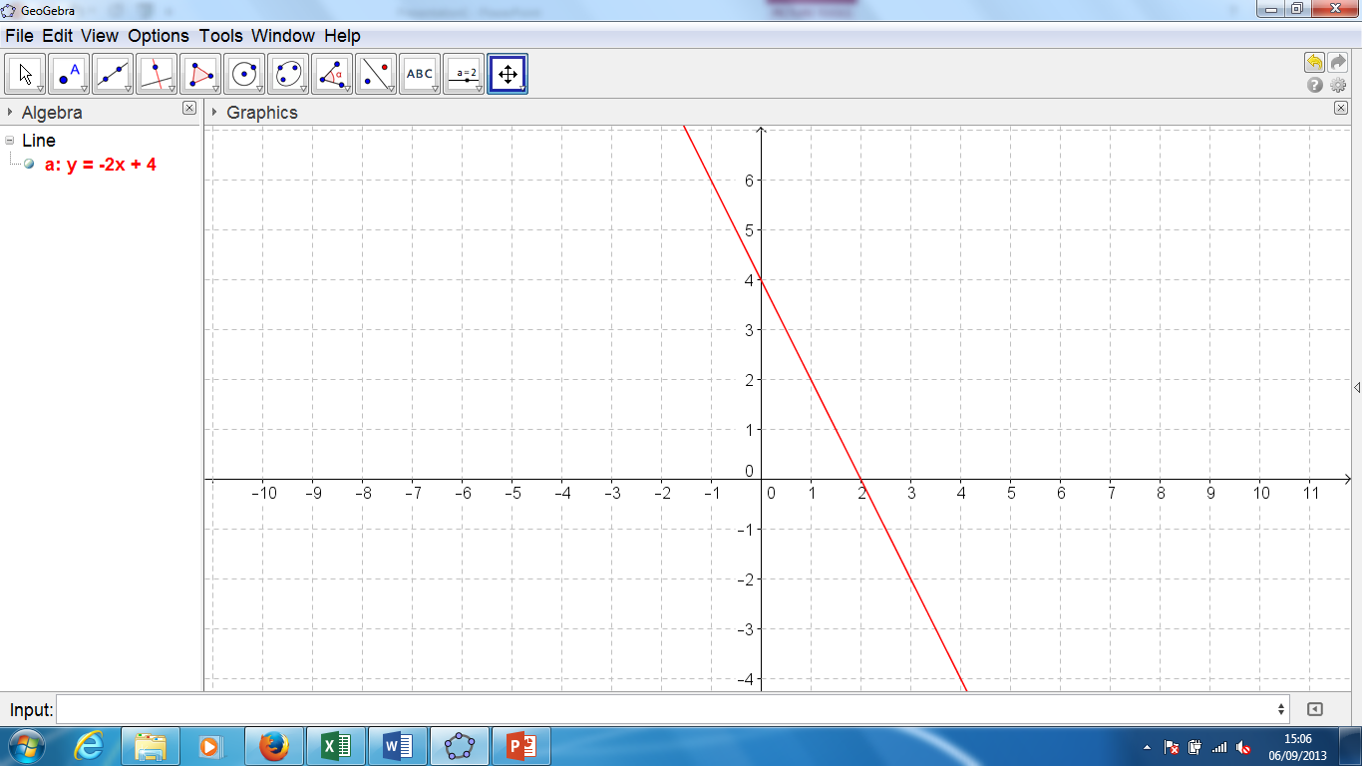

1. Find the midpoint of the line segment joining the points (5, 19)and (-1, 8).
2. Expand **.**
3. Factorise **.**
4. Complete the square **.**